This is an explanation of how to use the Pawel Jalocha SP9VRC mfsk files
mfsk_tx and mfsk_rx and mfsk_trx and the
Olivia-Aid files by Chris Watts VK3DNH

THE ABOVE FILES HAVE BEEN TESTED WITH W2000 AND WINXP

W98 users will not be able to use these files – Chris is working on doing
Another program for W98 users

These help files try to explain how to use the Olivia-Aid program to make the operation a little easier .

Run the program by clicking on the file
OliviaAid.exe or make a shortcut to this file and put it on your desktop
When executed this will bring up

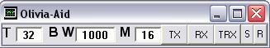

BUTTON EXPLANATIONS

The T box figures are the number of tones you want to use 2 4 8 16 (32) 64 128 256
The BW box is the bandwidth in hz - 125 250 500 (1000) 2000
The M box is the setting for how wide the receiver will look for the signal
default is 16
=======================================================

The M value may vary from 2 to 156...
Here some combinations of M and resulting tuning tolerance.
ALL IS VALID ONLY FOR T=32 and BW= 1000.
For other T and BW the tuning tolerance is different.

M Tuning tolerance (Hz)
2 +/- 31.2
4 62.5
8 125.0
16 250.0
32 500.0
64 1000.0
128 2000.0....
The wider the tuning tolerance is the more calculation power is needed.
---------------------------------------------------------------------
Right click on “T” brings up the Buffer window
Left click on “BW” will bring up the version box
Right click on “BW” bring up a window displaying all of the .log files in the current directory
Right click on TX Brings up the Com port selection box

If you wish to use Vox operation – leave the box blank
Vox is the easiest to use - when all text or files in the Transmit window are transmitted it will automatically return to receive

IF you do set a com port number – REMEMBER that you must WAIT until all of
Transmit window contents are displayed in the Receive window (plus a little bit extra) before you click on the RX button
IF YOU CLICK THE RX BUTTON PRIOR TO THIS IT WILL IMMEDIATELY RETURN TO RECEIVE

Single screen operation
Separate TX and RX screens

Click on RX to bring up the receive screen – close by clicking again on the RX button
For those that only want to receive

There is no provision to set any soundcard offset when using
The mfsk_tx and mfsk_rx files

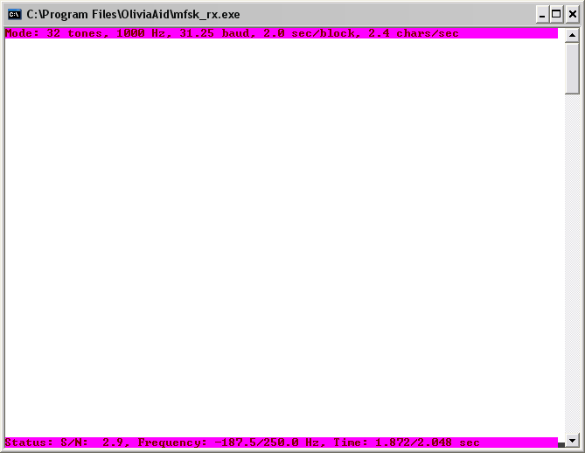

Right click on TX and it will bring up the com port selection box – enter
the com port number – if you wish to use VOX leave the box blank

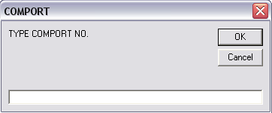

Click on T X and Transmit and Receive windows will come up and the program will begin transmitting ---- type to the transmit window or load from the buffer – when finished click on the RX button to go back to the Rx screen

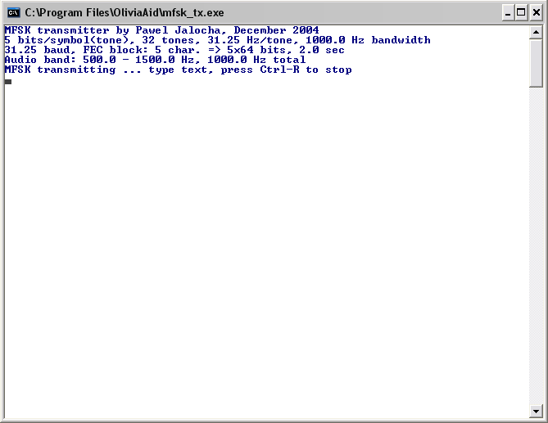

These are the basic principles of single screen operation

-------------------------------------------------------------------------------------------------------

Next for operation using the mfsk_trx.exe file

Right click on the TX box and it will bring up the com port selection box

enter the port number – then click ok - or if you want to use VOX make sure there is no entry in the com port setup box

If you do decide to use a com port - REMEMBER - that if you click on the RX button
when in transmit it will drop the PTT - you have to wait until you see
all of the sent text appear in the RX window (plus a little extra time) before clicking on the RX button

Click on the TRX button – a sound card setting box will appear – default is 8000
You can edit this box to reflect any TX offset that you may have

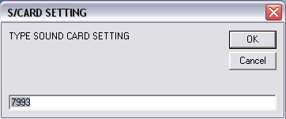

Click OK and it will bring up the Split Screen terminal and the program will be in receive at this point
To transmit – click on the TX button and type to the Transmit or load a file - when finished typing click on RX button to return to the receive screen
If using VOX operation it will automatically return to receive when all of the contents of the transmit window are sent - If using PTT do not hit the RX button until all of the
Transmit window contents have been displayed in the Receive screen
That is the basic operation procedure for using the TRX file

Picture below shows my setup here with Gram running s well as the TRX
Screen and also OliviaAid and the Buffer window open

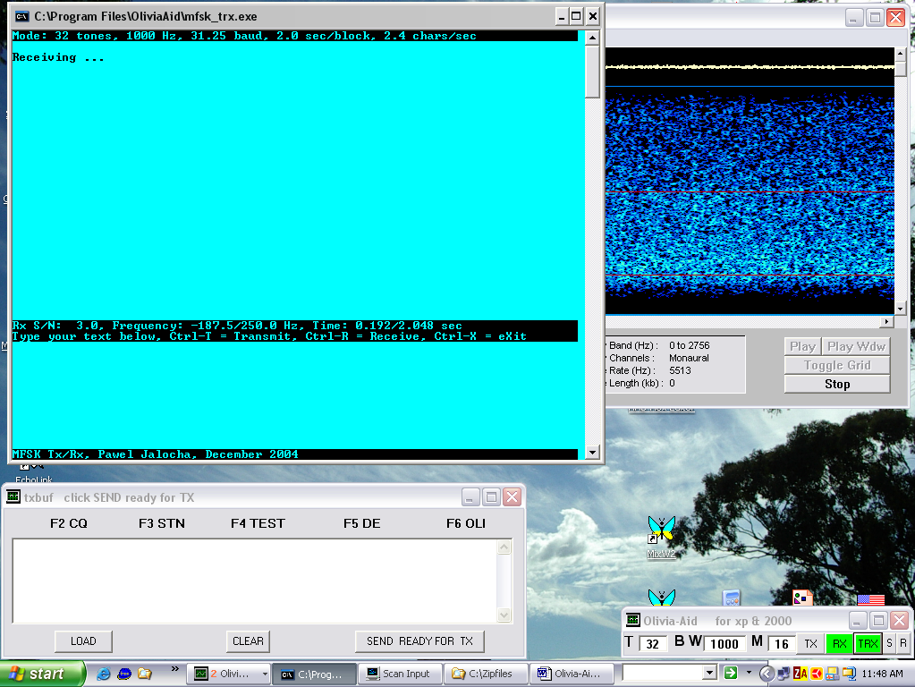

Now for the Buffer operation

You can type into the Transmit window even while you are receiving to have text
ready to transmit or you can use the Buffer window - use of the buffer is recommended since you can use Backspace there – but you cannot use backspace from the Transmit window

Right click on the “T” to bring up the Buffer

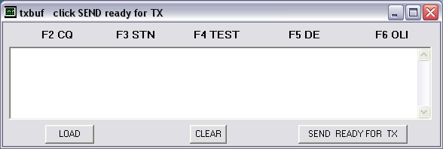

You can type directly to the Buffer window

or select a file by clicking on LOAD

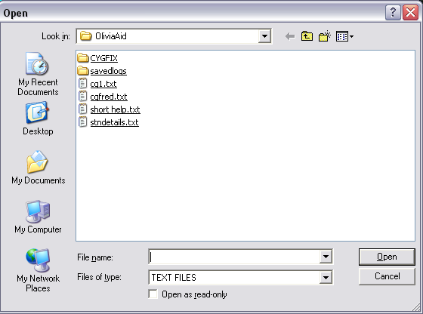

Brings up the file selection selection box – select the file you want to transmit – click OK - it will automatically load to the Buffer window (you can also copy and paste any text from anywhere on your computer in text as well) You also have use of the backspace function if you use the OliviaAid buffer
YOU CANNOT USE THE BACKSPACE FUNCTION DIRECTLY FROM THE TRANSMIT WINDOW
You can send one lot of text/files from the buffer to the Transmit window
by clicking on the SEND READY FOR TX button
The text loaded to the Buffer window will disappear when you click the SEND READY FOR TX button and will be pasted to the Transmit window and you can then use the buffer again for more text or files and again send this to the Transmit and so on
--- then click TX to transmit - you can also type directly into the transmit window while transmitting if you wish - when finished typing or loading files click RX which will take you back to receive when the Transmit window contents are finished

Buttons F2 thru F6 can be used for storing pre-prepared items such as CQ – station details etc

To save messages to the F key locations you have to do the following
Place the Cursor into the Buffer text window
CTL plus F key number
Type into the window that appears the text you want in that F key location
Hit Escape key
Hit SHIFT plus the F key number
Brings up a box in which you can enter the name for the F key
Click OK - it is then saved to the COMSettings file with a .dnh extension

All you need to do then to send the contents is click on the F2 (etc) button to paste it to the Buffer window
You can also hand type to the Buffer or load text files from anywhere on the computer
You can also continue to type to the Buffer as well – when finished click on the
SEND READY FOR TX and the contents will be pasted to the Transmit window and the buffer contents will be cleared
You can continue to add information to the buffer by typing or adding files or the F keys
But you must hit the SEND READY FOR TX button each time you want to sent the Buffer contents to the Transmit screen
When finished click the RX button

Right click on the BW

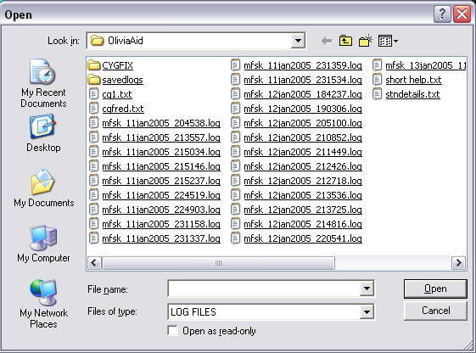

RIGHT click on any file and it will bring up a drop down menu in which you can do a number of functions

LEFT click on any of the .log files brings up a box

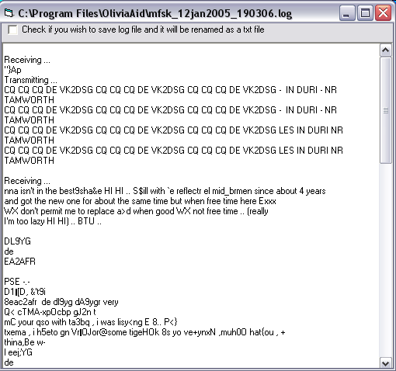

If you check the box you can save the file as text file a in the savedlogs
Folder in Olivia Aid by closing the window

Regards
Les VK2DSG 12 JAN 2005

